Steps:

1. Create a virtual environment

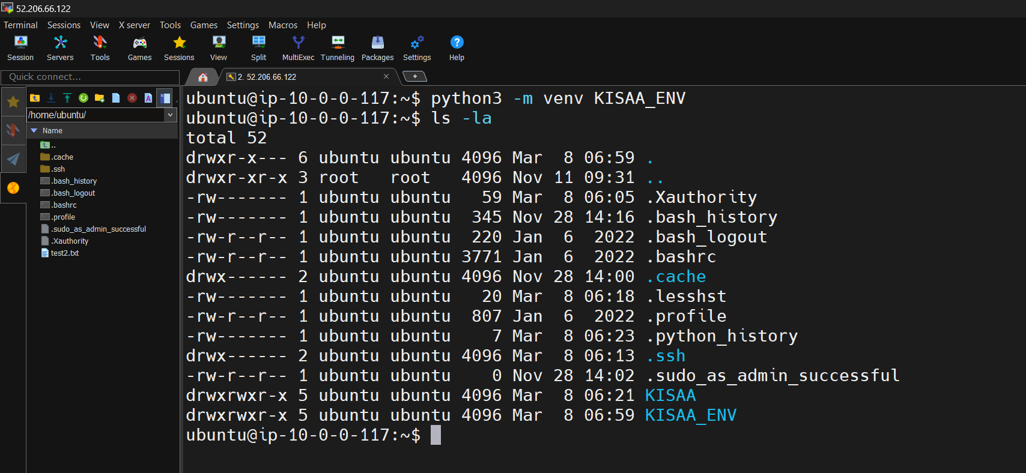

1. Activate Virtual Environment

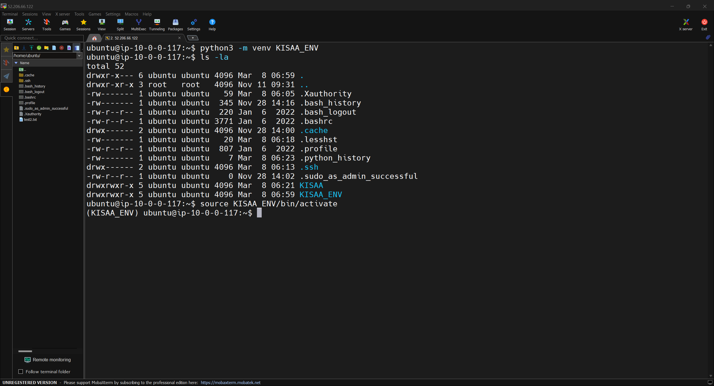

1. Clone the repository

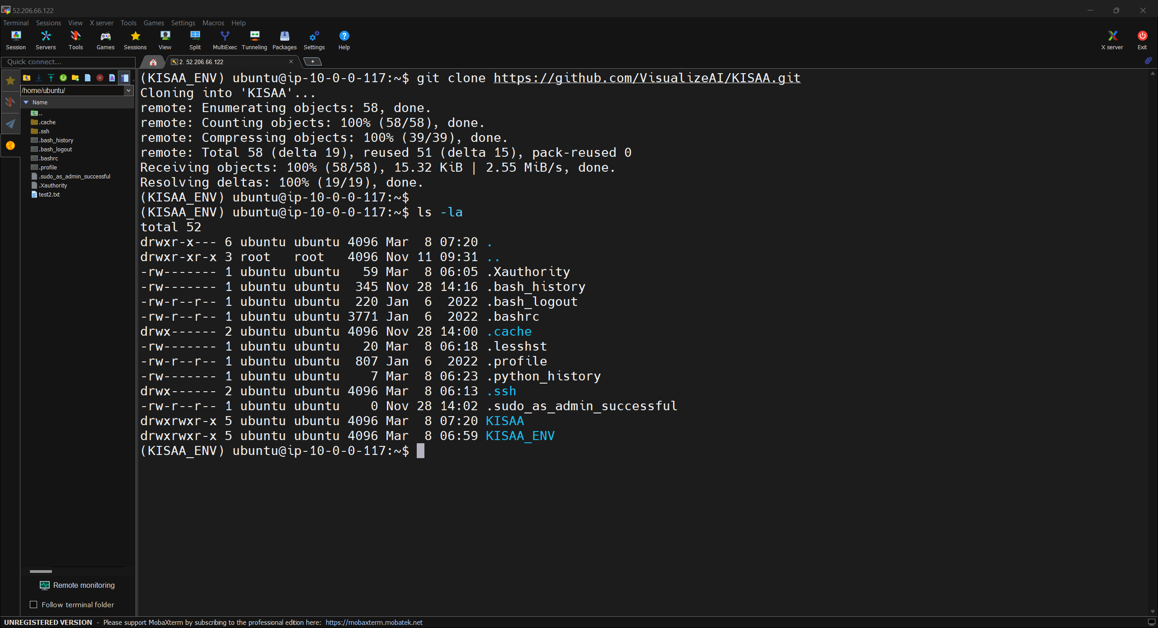

1. Install dependency packages from the requirements.txt file

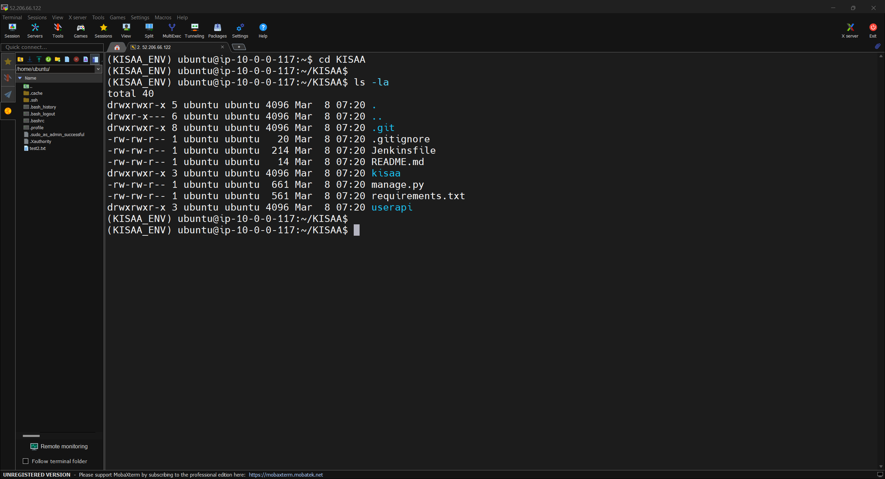

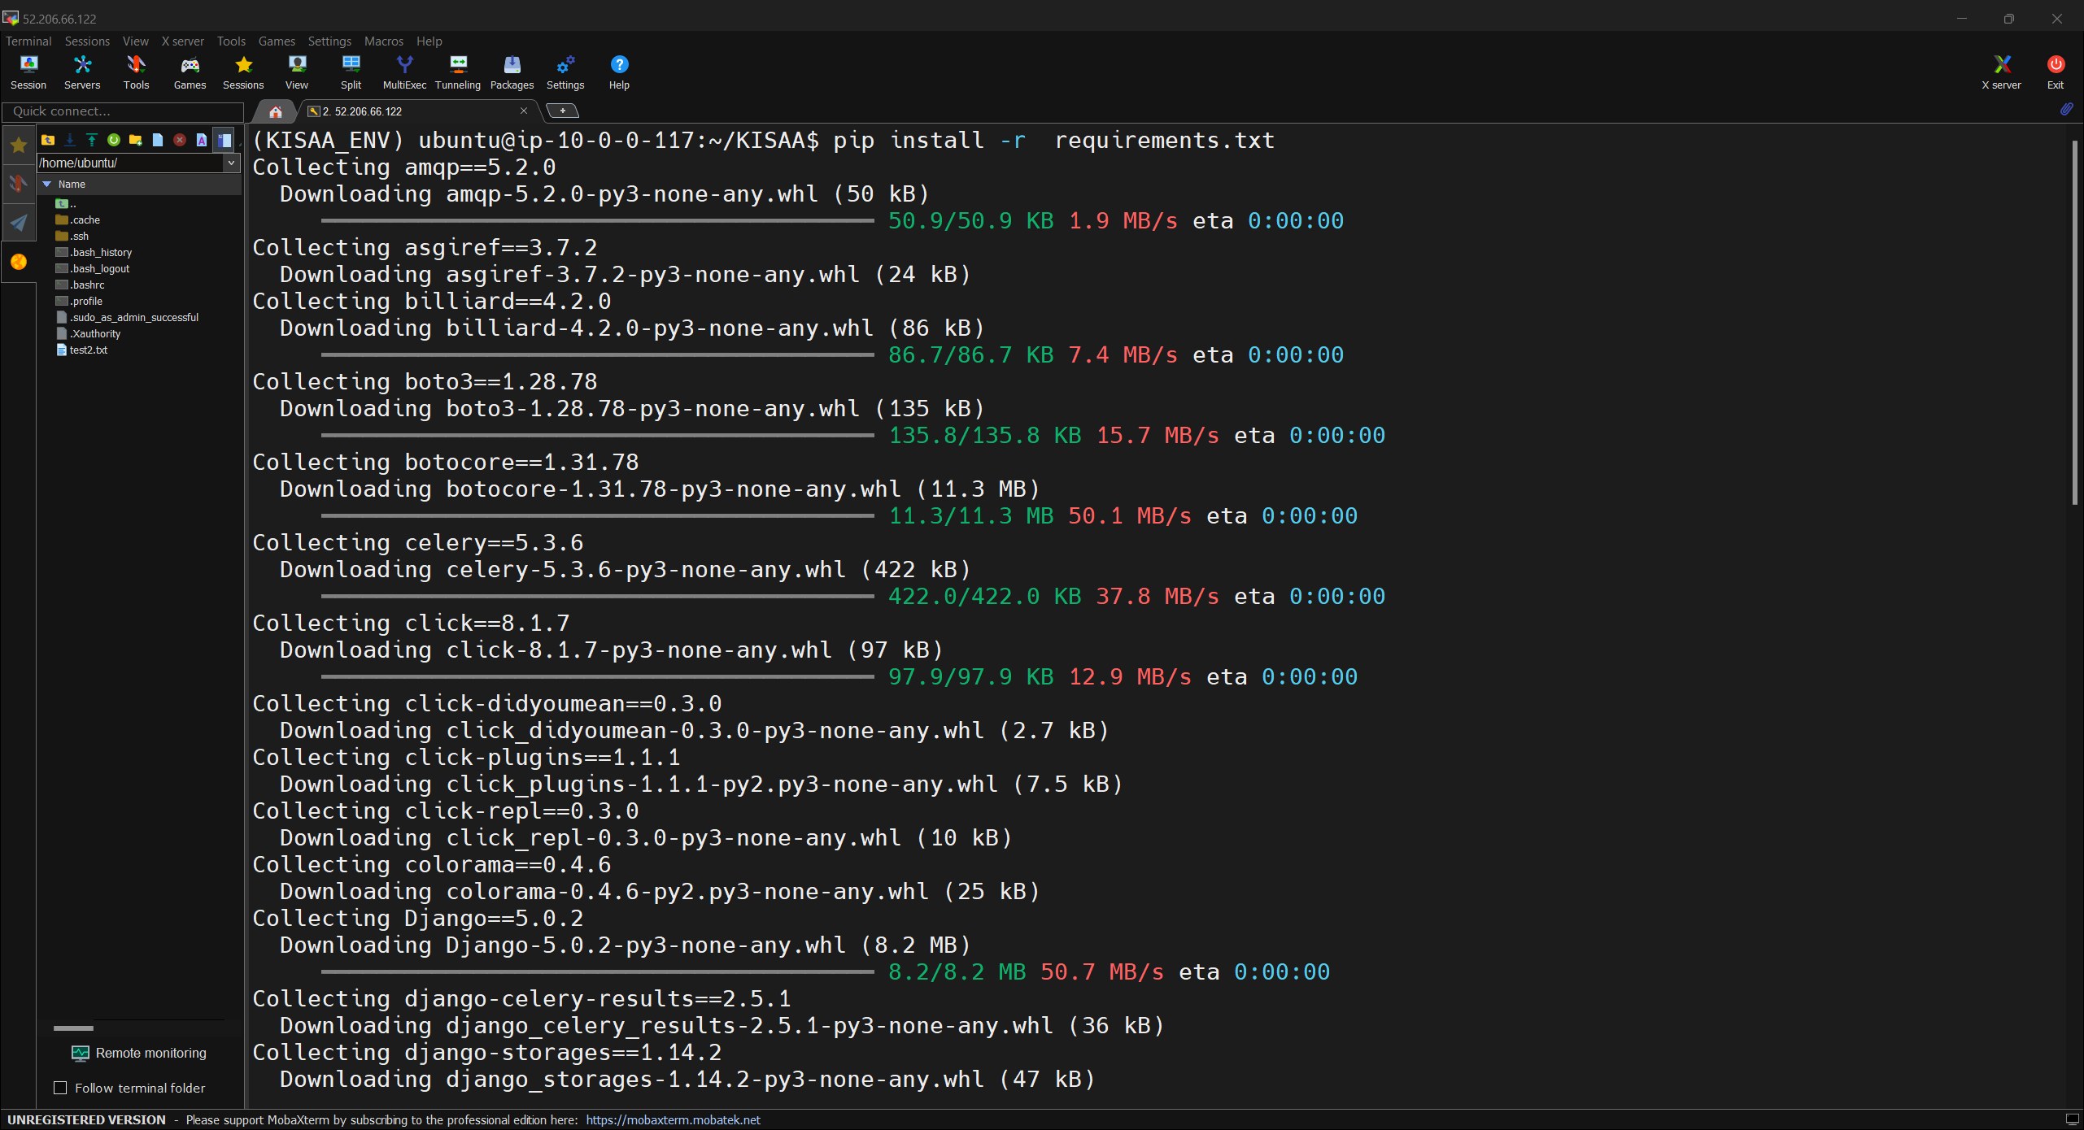

1. Create/copy the “.env” file which will have all sensitive data like passcodes, secret keys etc.

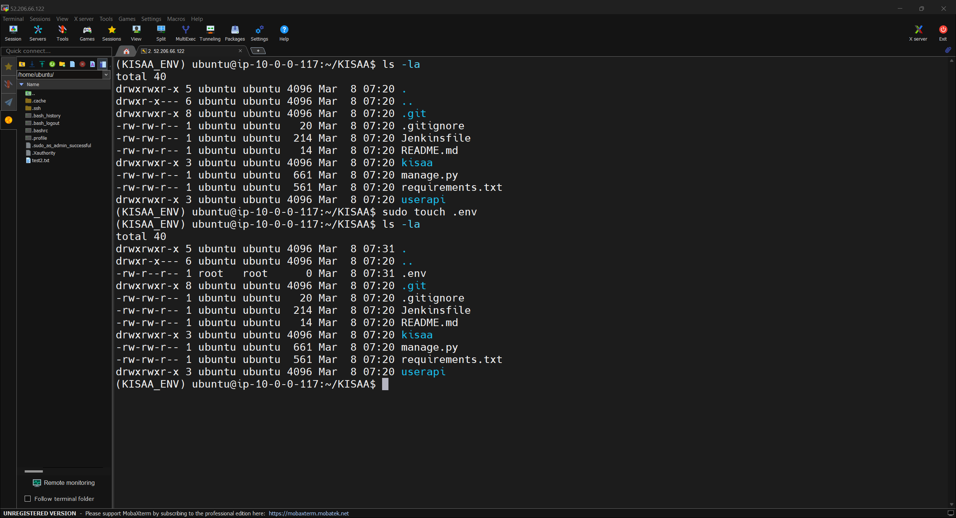

1. Edit the file and paste values (if newly created)

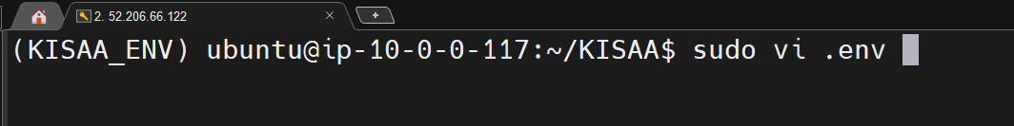

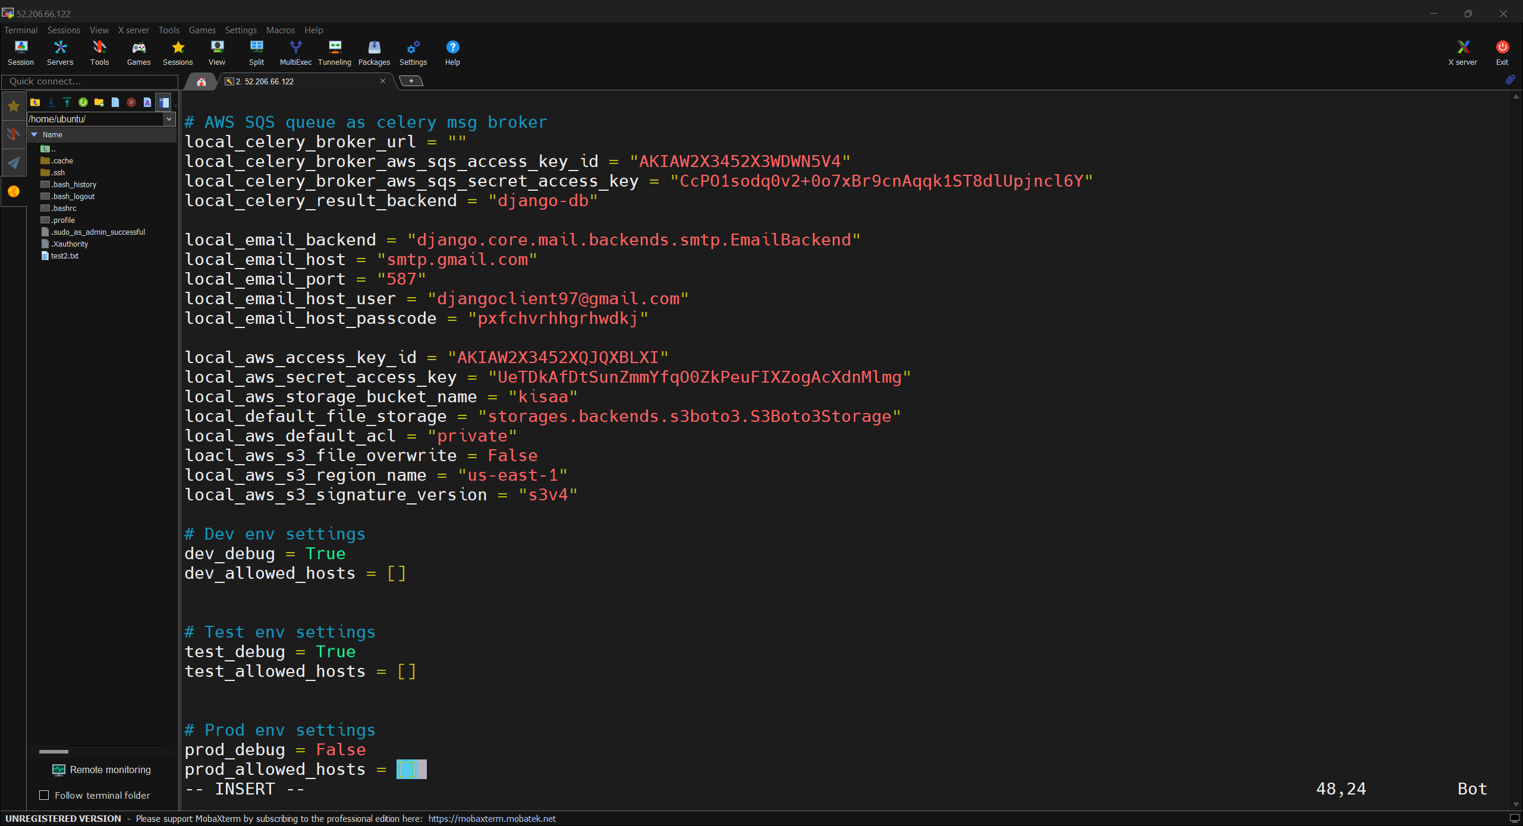

Copy and paste the values from the local file.

Save the file.